Chapter 10, Solution 34.

The circuit is shown below.
5 
4090 V
+
−
I₁
I₃
I₂
3 A
10 
20 
j15 
8 
j4 
-j2 
I_{o}

For mesh 1,
(1)

For the supermesh,
(2)

Also,
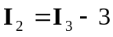 (3)

Adding (1) and (2) and incorporating (3),
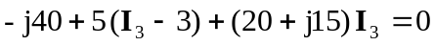
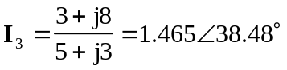
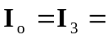 1.46538.48 A

